What Is Reflexology
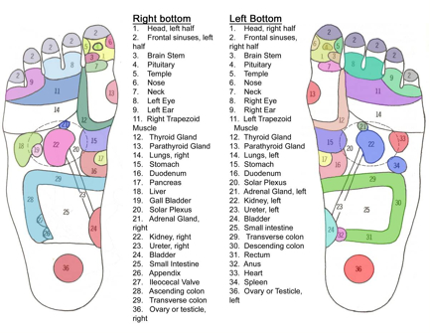
Foot Reflexology Chart
Reflexology is a non-invasive practice applying alternating pressure using the thumb and fingers to reflexes on the feet, hands and outer ear as shown on a reflex map of the body. Pressure is applied to these areas affects the organs and systems of the body improving the person’s overall health. This procedure can alleviate stress, rid the body of toxins created by illness and relieve pain.

Why You Should Try It
Here is a partial list of some health conditions benefitted by reflexology:
- Anxiety
- Arthritis
- Back Pain
- Circulation
- Diabetes
- Headaches
- Menopause
- Ringing in the ears
- Sinus Congestion
- Sleep improved
- Stress

